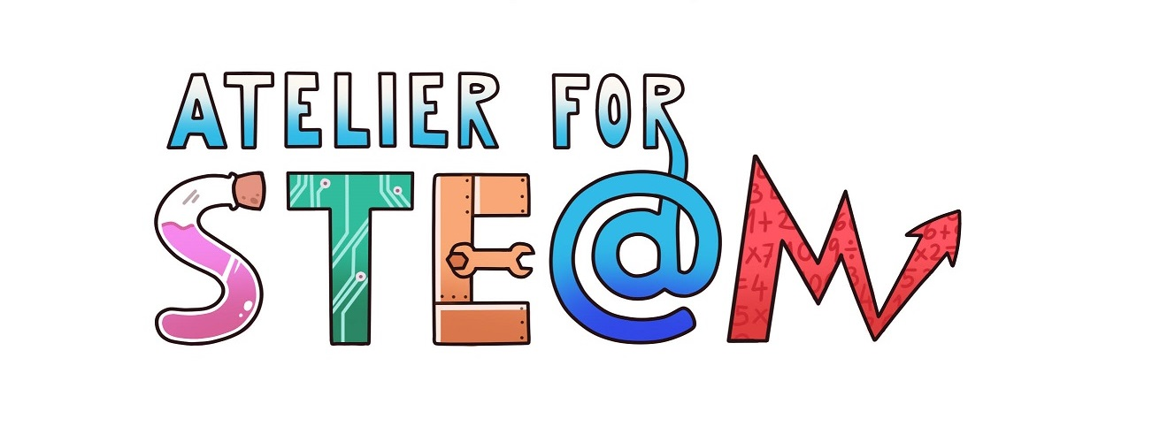 | Atelier for STE(A)M project.
Title | Working cooperatively the Periodic Table
Content knowledge | Periodic table of elements.  Characteristics and arrangement of the elements in the periodic table.  Periodicproperties.
Methodology | Mobile Learning-Cooperative Learning
Technology | Mobile phones  Merk PTE App(https://play.google.com/store/apps/details?id=de.merck.pte&hl=es_419)
Duration | 1 session (50 minutes)
Target group (age, course) | 15-16 years (4th Secondary)
Resources | App Merk PTE (https://play.google.com/store/apps/details?id=de.merck.pte&hl=es_419)
Learning Objectives, Skills and competencies  (aims to be accomplished) | That the students handle the periodic table and know how to look for properties of the elements.  That they know a tool that allows to look for elements that meet certain conditions (physical properties and chemical properties)  That the students work cooperatively in the resolution of the proposed activities.  Know how to distinguish the relevant information from the non-relevant one.  Learntolearn.
Learner’s Role  Learning space | The activity was developed in the form of cooperative work, defining the following roles:  Coordinator (Coordinates and encourages team work).  Responsible for time (manages the time for its good use).  Spokesperson (handles the phone, puts in common).  Secretary (complete the activity file provided by the teacher).
Description(of every lesson)  Scenario Narrative | The day before the activity, students were told that they would carry out a cooperative work activity with the Merk PTE application and that it would be necessary to have it installed on a mobile device (1 phone per group). The teams were formed and it was decided which student from each team would be responsible for installing it.  At the beginning of the activity, teams of 4 students were organized. As the number of students was not a multiple of 4, there were two teams of 4 students and two teams of 3 students in which one student assumed two of the defined roles.  A file was passed in which the students had to write down their names associated to the corresponding role. The same file contained the activities that the students had to carry out, as well as a self-evaluation and final reflection (See Annex).  Once the activities were carried out, they were put in common. The spokesperson of each team shared the answers.
Learning | The activities carried out were:  a) What do you think the colors that you see in the periodic table represent?  b) What are the most important characteristics of Erbium?  c) Who discovered the Radio?  d) Which elements are liquid at room temperature? And gaseous?  e) Which elements can be found solid above 3000ºC?  f) In 3000 BC, what elements were known?  g) What is the most electronegative element (which has the greatest tendency to attract electrons in a bond to itself)? And the one with the least electronegativity?  e) What is the element with the highest atomic radius?
SEN (Reinforcement or ampliation)  Conclusions | No extension or reinforcement activities were considered.  Conclusions: it is interesting to propose activities that involve different methodologies and technologies. Cooperative work ensures that all students perform the activity properly.
Improvements | One more question could be added to the question file since it would have been time to resolve it. Put more demands on the establishment of roles (a team did not define the roles well and had to insist on the importance that this has).
evaluation/assessment | The objectives of the activity were met.  The students state that they have not had great difficulties in handling the application (the ones that have arisen have been solved by searching) and that what they have learned will be useful in this and subsequent courses.

Annex: Tab of the complete activity.
App Merk PTE
Coordinator (Coordinates and encourages team work):
Student's name:
Responsible for time (manages the time to take advantage of it):
Student's name:
Spokesperson (handles mobile, puts in common):
First name:
Secretary (complete the form):
Firstname:
a) What do you think the colors that you see in the periodic table represent?
b) What are the most important characteristics of Erbium?
c) Who discovered the Radio?
d) Which elements are liquid at room temperature? And gaseous?
e) Which elements can be found solid above 3000ºC?
f) In 3000 BC, what elements were known?
g) What is the most electronegative element (which has the greatest tendency to attract electrons in a bond to itself)? And the one with the least electronegativity?
e) What is the element with the highest atomic radius?

Reflection and self-evaluation questions (complete the coordinator by consulting the other members):
• Time spent on the activity? ......
• Has each person fulfilled the assigned role?
• What have you learned?
• What difficulties have you encountered?
• How have you solved those difficulties?
• What is the use of what you learned (when faced with similar problems)?

For the teacher
 | 4 | 3 | 2 | 1
Cooperative work | The group has been organized according to the roles and adequately develops the activity. | The group has been organized according to the roles and adequately develops the activity. Onoccasion he getsdistracted. | The group has NOT been organized according to the roles, although they carry out the activity. Some people in the group only watch.. | The group has NOT been organized according to the roles, and some people in the group only watch. Sometimes, they talk about things that are foreign to the activity.
Individual work | He works properly according to its role: it carries out the proposed activities. | Occasionally he becomes distracted and talks about things unrelated to the activity. | Does not fulfill the assigned role. | Does not participate in the activity.

