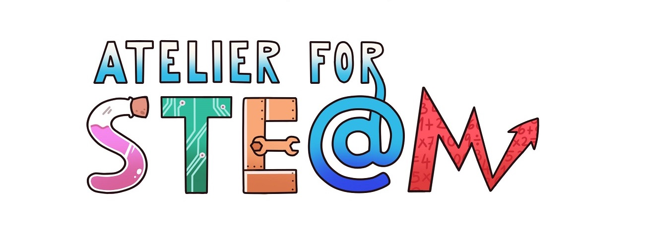 | Atelier for STE(A)M project.
Title | Ice inquiry
Content knowledge | Dissolutions  Properties of water  Convection current  Factors that intervene in the changes of state
Methodology | Inquiry  Debate and argumentation
Technology | Mobile device: photo and video camera  Video editor
Duration | 1 session in class (50 min.) 1 session at home (1 h.)
Target group (age, course) | 3-14 years (3rd Secondary) and 14-15 years (4th Secondary)
Resources | Inquiry form provided by the teacher (supplementary material).
Learning Objectives, Skills and competencies  (aims to be accomplished) | That the student understands the scientific method  Perform a simple experiment  Record experiences taking pictures and videos  That students work as a group organizing tasks.  Know how to distinguish the relevant information from the non-relevant one.  Learn to learn.
Learner’s Role  Learning space | The activity can be done in small teams or it could be done individually.
Description(of every lesson)  Scenario Narrative | The teacher presents the activity and gives a file to each team (5min.)  Students perform the activity at home, take notes and record the experience (photography and video). They try to draw conclusions.  Sharing of the results (45 min.). Each team briefly presents the results. The teacher could lead to an explanation of the phenomenon or reproduce the experience in front of the students to observe what happens.
Learning Activities | a) Read carefully the file provided by the teacher and follow the instructions carefully. If there is a word that you do not recognize, look for information.  b) Make the experience using the card.  c) Take record of what happened.  d) Discuss the results in your group.  e) Expose your ideas to the other teams.
SEN (Reinforcement or ampliation)  Conclusions | The same experience can be done with different salt concentrations.  You can take temperatures and see if it varies with time.  Look for other situations in which this phenomenon is revealed.  Conclusions: this activity allowed analyzing the strength of the learning of the scientific method.
Improvements | Perhaps it would be interesting to ask the students to prepare a technical report.
evaluation/assessment | The experience has been very interesting to analyze the scientific methodology in a tangible way.

APPENDIX
An ice cube, does it melt before in a glass of tap water or in a glass of salt water?
- 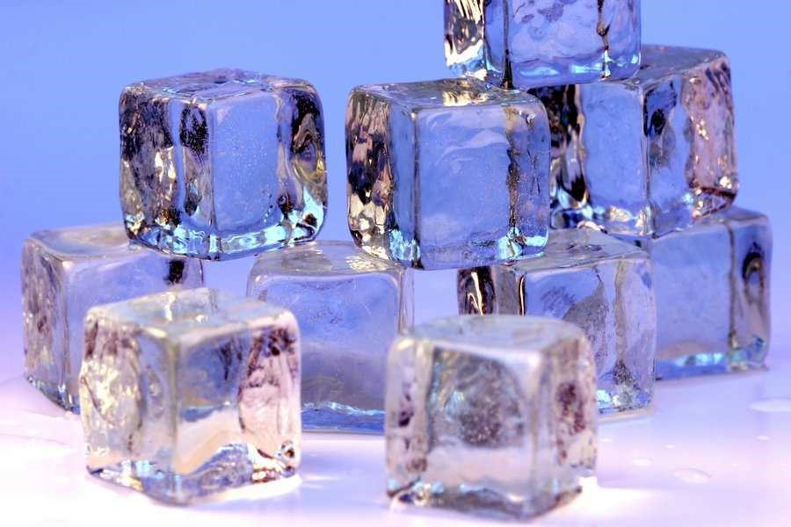Previous ideas. What do you think will happen? (Before doing the experiment). Write it.
- Insert an ice cube into a glass of water taken directly from the tap and another ice cube into a glass of water to which you have previously added salt. Let a little time go by and describe what happens.
- Build a hypothesis from the previous observation.
- Do tests and describe thoroughly what you do and how you do it. Try different amounts of salt. Try dissolving sugar. What happen? Repeat the experiences if you need to be sure. Make a table explainingtheobserved. Forexample:

Water directly from the tap | Water with disolved salt* | Water with sugar*

- In view of the results obtained, draw conclusions about the starting hypothesis or think about a new hypothesis.

Note: It is important that you document the entire research process, besides taking notes and making drawings, through video and photography.
* Saturated solutions.
Picture: "Ice cubes openphoto" by Darren Hester - Openphoto.net. Licensed under CC BY-SA 2.5 via Wikimedia Commons https://commons.wikimedia.org/wiki/File:Ice_cubes_openphoto.jpg#/media/File:Ice_cubes_openphoto.jpg
Experiencebasedin: Pinto, G & Lahuerta, P (2015). Velocidad de fusión del hielo en distintas disoluciones: un ejemplo de aprendizaje activo de la Ciencia. Educació Química.

