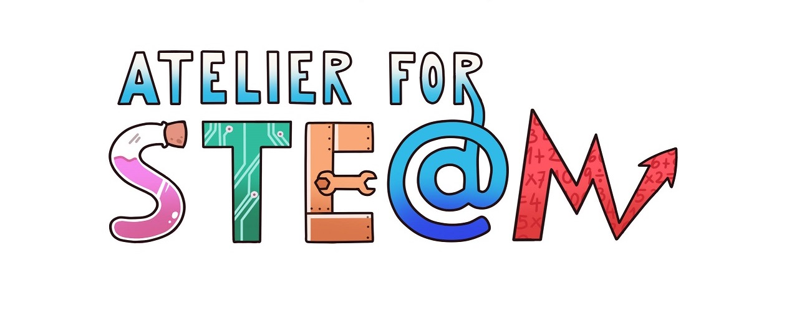 | Atelier for STE(A)M project.
Title | Odour Research
Content knowledge | The smells. The sense of smell.  Odoriferous pollution.  Characterization of odors.
Methodology | Project-based learning, Team work.
Technology | App OdourCollect: https://play.google.com/store/apps/details?id=es.nobone.manchesterwebapp&hl=en_US  PC / Internet  Video camera  Video editor software  Mobile phone
Duration | 8 sessions (50 minutes per session).
Target group (age, course) | 15-16 years (4th Secondary)
Resources | The main source was the Odour Collect Didactic Unit:  - Odourcollect Didactic Unit, accessible in: https://ciencia-ciudadana.es/disponible-la-unidad-didactica-ciencia-ciudadana-para-monitorizar-la-contaminacion-odorifera/  Othersourcesconsulted:  - Odoriferous pollution. AEC. https://www.aec.es/web/guest/centro-conocimiento/contaminacion-odorifera  - Odoriferous pollution. Department of Territory and Sustainability. http://mediambient.gencat.cat/es/05_ambits_dactuacio/atmosfera/contaminacio_odorifera/
Learning Objectives, Skills and competencies  (aims to be accomplished) | That the student understands the importance that the smell plays in our perception of the environment.  That the student knows what is the odoriferous pollution and the main focuses.  That the student uses a mobile application to characterize smells.  That the student uses a mobile application to locate foci of odoriferous pollution.  That the student becomes aware of the impact of human activity on the environment.  That the student carries out an investigation following the appropriate guidelines.  That the students work cooperatively in the resolution of the proposed activities.  Know how to distinguish the relevant information from the non-relevant one.  Learn to learn.
Learner’s Role  Learning space | In this case, a single team was formed in which the 9 students taking the course participated. It was named:  Coordinator: coordinates and encourages team work. It is a reference for work organization and communication with the teacher.  Secretary: collects notes on the minutes and prepares reports that must be presented to the teacher.  The tasks were defined and distributed among the group's components.  We worked in the classroom and in the computer classroom.  The students did field activities to locate foci of odoriferous pollution in the city.
Description(of every lesson)  Scenario Narrative | Step 1. We form a team and appoint a coordinator and a secretary.  Step 2. We met and discussed what tasks could be done to investigate odors and we shared them among the team members. Subsequently we discussed what disclosure tasks we wanted to do and organized them.  Step 3. For objectives 1 and 2, we are trained using the aforementioned teaching unit and with some explanations from the teacher. From there we learned:  - What is the smell, how it is processed, characteristics of the smell, what is the odoriferous pollution and its importance, etc.  - Use the Odour Collect application to geolocate odors.  Step 4. We traveled through Burgos by bicycle and geolocated different points of odor pollution using the application. In addition, we read the comments of other users.  Step 5. For the objectives 2, 3 and 4, for the data collection we elaborated a test of questions that later we composed in a form of Google (https://forms.gle/Ursk3tZ3AY2XcmT58), in order that it was more comfortable to collect the data directly with our phones and their subsequent treatment.
Learning Activities | 1. Explore:  a) What is the smell? How is the perception of the smell produced? How is an odor characterized?  b) What is odor pollution?  c) What are the main points of odor pollution?  2. Investigate:  a) How functional to Odour Collect application?  b) Are there any points of odoriferous pollution in your city? Geolocalizate.  c) What are the favorite aromas of the people? Take data and analyze them.  3. Communicate:  a) Create dissemination elements: posters, models, videos, etc. to publicize your research.  b) Create a scientific-technical report and prepare a press release.
SEN (Reinforcement or ampliation)  Conclusions | The distribution of tasks and the development of them is done according to the abilities of the students.  Conclusions: the project has been very interesting for students who have worked as a team.
Improvements | Dedicate more sessions to the Project so that the investigation is more profound.
evaluation/assessment | The objectives have been met.  Investigation: https://apollo21.wordpress.com/odour-research/  Video explanation: https://youtu.be/BclaasvqR8g
