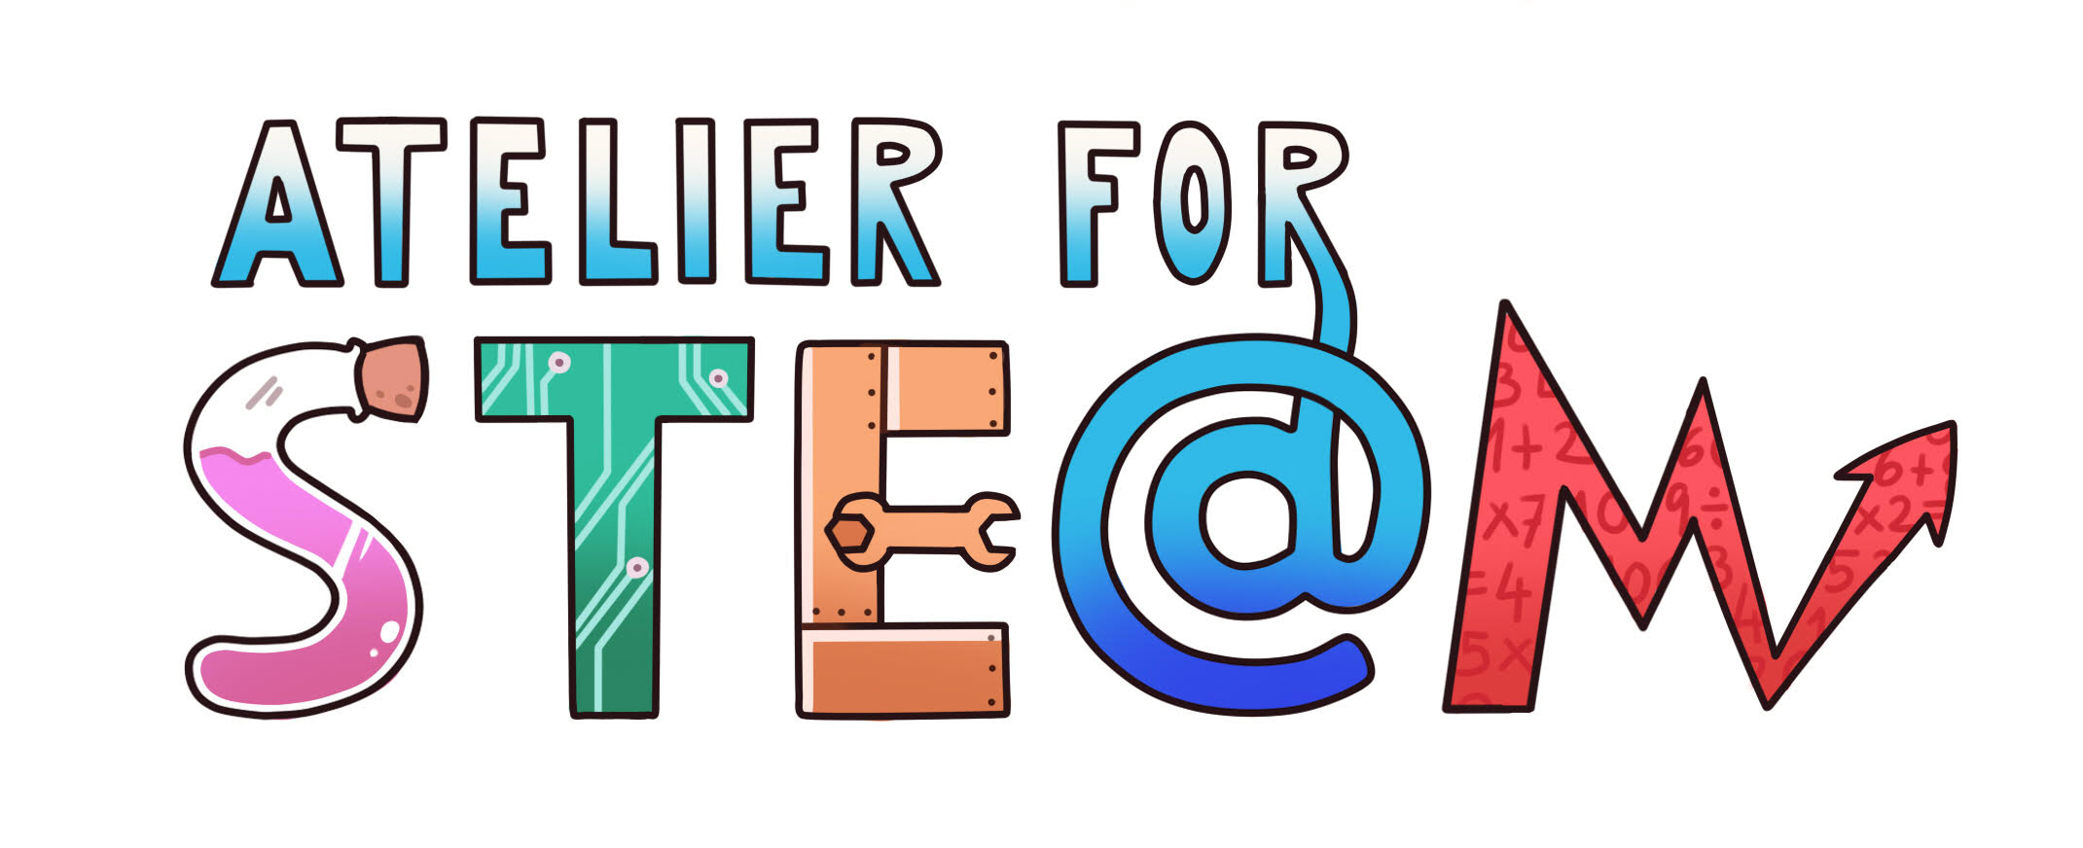 | Atelier for STE(A)M project.
Title | Density
Content knowledge | Measuring and calculating density of liquids and solids.
Methodology | Hand-made measuring tool, aerometer, to measure density
Technology | Kahoot, PPT
Duration | 45 min
SAMR model (level of transformation technology produce) | Use of Kahoot
Target group (age, course) | 14-15 years old, Physics
Resources | Computer, smartphone
Learning Objectives, Skills and competencies  or. (Aims to be accomplished) | - Students learn that density of a substance is its mass per unit volume.  - The students use $d=\frac{m}{v}$ to calculate density of liquids.
Didactic sequence  -Description of every lesson  with added attention to the diversity of students | Older students introduce themselves and explain what aerometer is and what we use it for.  Students get into groups of 4. Then older students demonstrate how an aerometer is made. Each student makes their own aerometer and uses it to measure density of two liquids (oil, water). They calculate the density of the two liquids using $d=\frac{m}{v}$ .  By using the aerometer they deduce the density of unknown liquids (es. ethanol, syrup)  When all students complete their tasks, they participate in the Kahoot quiz. https://create.kahoot.it/share/gostota/ad531e61-305d-4ab4-bd3c-5f9869d70f79  - What is an aerometer?  - Speedometer.  - Density meter.  - Moisture meter.  - Pressure gauge.  2. What is the base unit for density?  - m3 / kg  - kg / dm3  - kg / m2  - kg / m3  3. Sort substances by their density from the lowest to the highest: oil, ethanol, water, juice syrup.  - Oil, ethanol, water, juice.  - Oil, juice, water, ethanol.  - Oil, ethanol, juice, water.  - Juice, ethanol, water, oil.  The aerometer sinks deeper in the fluid  - which has a higher density.  - which has a lower density.  - The aeriometer always sinks equally.  - What is an aerometer?
Evaluation  (what are we going to evaluate, how, whom…) | The students’ knowledge will be tested through written exams.
Conclusions | To make a measuring tool, one doesn’t need much money nor time; we can create it ourselves - it’s fast and practically cheap.
Improvements | Students have improved their experiment skills and public speaking skills.

