Learning Slovenian words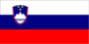
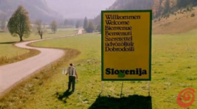

NUMBERS = števniki/številke
1 = ena
2 = dva
3 = tri
4 = štiri
5 = pet
6 = šest
7 = sedem
8 = osem
9 = devet
10 = deset
20 = dvajset
100 = sto

Animals = živali
dog = pes
cat = mačka
bear = medved
fish = riba
horse = konj
rabbit = zajec
cow = krava
mouse = miš
bird = ptica/ptič
bee = čebela
proteus = človeška ribica

Colours = barve
yellow =rumena
green = zelena
black = črna
white = bela
blue = modra
red = rdeča
brown = rjava
orange = oranžna
pink = roza

Greetings = pozdravi
Hi! Zdravo!
Good morning! Dobro jutro
Good afternoon! Dober dan
Good evening! Dober večer
Good night! Lahko noč!
Good bye! Na svidenje!

Common questions/phrases
How are you? Kako ste kaj?
I'm fine, thank you! Dobro, hvala!
Good luck! Vso srečo!
Happy birthday! Vse najboljše za rojstni dan!
Happy new year! Srečno novo leto
Merry Christmas! Srečen božič
Congratulations! Čestitam!
Bless you (when sneezing) Na zdravje
What's your name? Kako vam je ime?
My name is (Laura …). Moje ime je …
Where are you from? Od kod ste?
Where do you live? Kje živite?

I live in (Italy/France …/ Slovenia).
Živim v (Italiji, Franciji …/Sloveniji).

How old are you?
Koliko ste stari? Koliko si star/stara?
I'm (fourteen, twelve) years old.
Star/-a sem (štirinajst, dvanajst) let.

You look beautiful! (to a woman) Zelo lepi ste!

Can I have your phone number?
Mi lahko zaupate svojo telefonsko številko? Mi poveš svojo telefonsko številko?

I like you! Všeč ste/si mi!
I love you! Ljubim te!

Sorry! (or: I beg your pardon!) Oprostite!
I don't understand! Ne razumem!
I don't know! Ne vem!
Can you help me? Mi lahko pomagate?
Help! Na pomoč!
Are you okay? Ste v redu?

In a shop
How much will it cost?/How much is this? Koliko stane?
Do you like it? Vam je všeč?
I really like it! Zelo mi je všeč!

Asking about time
What time is it?
Koliko je ura?
It's 3 o'clock
Ura je tri.

Transport = prevoz
Airport = Letališče
Bus station = Avtobusna postaja
Train station = Železniška postaja
Taxi = Taksi

Useful words = uporabne besede
Good = dobro
Bad = slabo
Big = veliko
Small = majhno
Today = danes
Now = sedaj
Tomorrow = jutri
Yesterday = včeraj
Yes = da
No = ne
Fast = hitro
Slow = počasi
Hot = vroče
Cold = mrzlo

Questions
What? Kaj?
Where? Kje?
Who? Kdo?
How? Kako?
When? Kdaj?
Why? Zakaj?

Drinks and food = pijača in hrana

Coffee = kava
Tea = čaj
Juice = sok
Milk = mleko
Cocoa = kakav

Bread = kruh
Soup = juha
Spaghetti = testenine
Potatoes and meat = krompir in meso
Vegetables = zelenjava
Fruit = sadje

Typical slovenian dishes

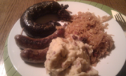

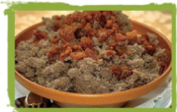

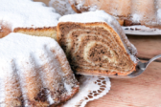

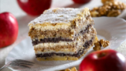

Slovenija has beautiful places

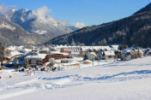
Kranjska Gora

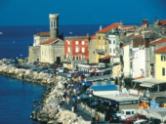
Piran

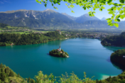
Bled

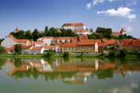
Ptuj

Capital city - LJUBLJANA

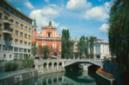

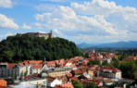

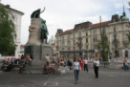

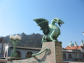

Famous people

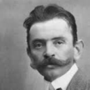
Ivan Cankar, writer
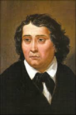
France Prešeren, poet

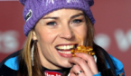
Tina Maze, alpine skier

...and our school – Gimnazija Moste, Ljubljana

