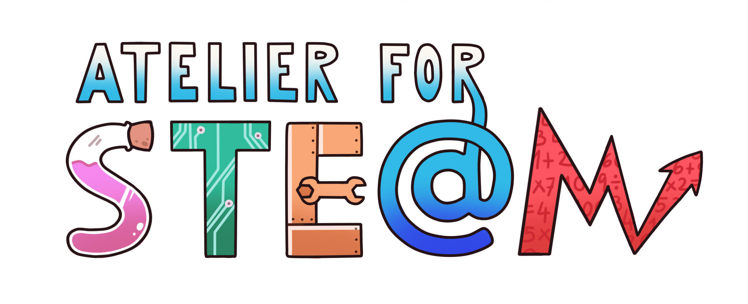 | Atelier for STE(A)M project.
Title | Learning Slovene language using English as teaching language
Content knowledge | Reading, listening and speaking (pronunciation) – food, greetings, numbers, animals, questions, places …
Methodology | Reading, listening and speaking (pronunciation)
Technology | Video production, PPT, Microsoft Word
Duration | 45 minutes
SAMR model (level of transformation technology produce) | Use of internet conversations between slovene people to practice pronunciation, spelling. Use of dictionary online. Video.
Target group (age, course) | 15, 16, 17, 18
Resources | Computer, smart board, paper shits, PPT, Word
Learning Objectives, Skills and competencies  or. (Aims to be accomplished) | Learning word in Slovene that we use in everyday life (for foreign students and teachers)  Use of IKT (video, PPT, internet, Word)  Development of digital competences
Didactic sequence  -Description of every lesson  with added attention to the diversity of students | Students were following the PPT presentation, which introduced numbers, animals, vegetation, places, colours, people, common questions and answers, food and drink …in Slovene – expressions were given to them in video and they tried to reproduce a similar conversation.  A teacher shows a word, explains the meaning and asks students to repeat. (the video is private, so it is not distributedonYoutube yet.)
Evaluation  (what are we going to evaluate, how, whom…) | Students tried their language skills in town, when they tried to order food, read signs and talk to a Slovenian, asking for directions to the station in Slovenian.
Conclusions | When we travel it is fun and wise to learn some useful words we can use to order food, understand the signs, make a simple conversation, ask for directions…learning foreign languages makes us closer to others
Improvements | They have improved the following language skills: reading, writing, speaking and listening, as well as developed digital competences.

