DENSITY OF LIQUIDS

TASK: Create your own aerometer (an instrument designed to measure density) and deduce the density of liquids.
EQUIPMENT:
- a straw
- playdough
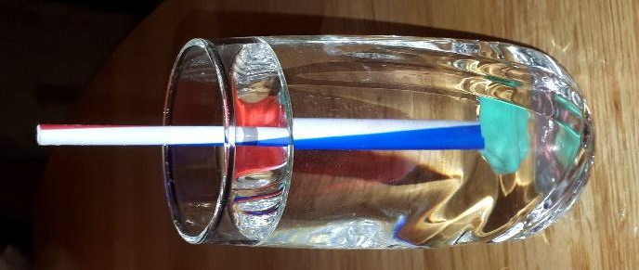
- quartz sand
- various liquids
- measuring cylinder

Scientific background: The density, or more precisely, the volumetric mass density, of a substance is its mass per unit volume. ($d=\frac{m}{v}$).
Instructions:
- Take some water and weigh it.
- Take some oil and weigh it.
- At the bottom of the straw, attach some playdough to close it and block air. Then add some quartz sand into it.
- Put the aerometer you have just made into a glass of water and into oil, separately to measure density.
- Put your aerometer into other liquids and tell their density.
Measurements/results:
 | mass (kg) | volume (dm³) | density (kg/dm³)
water
oil

Density of 1st liquid:
Density of 2st liquid:
Sort the liquids according to their density:

Conclusion: The aerometer sinks deeper into the liquid that has ________ (bigger/smaller) density.

