Water lesson
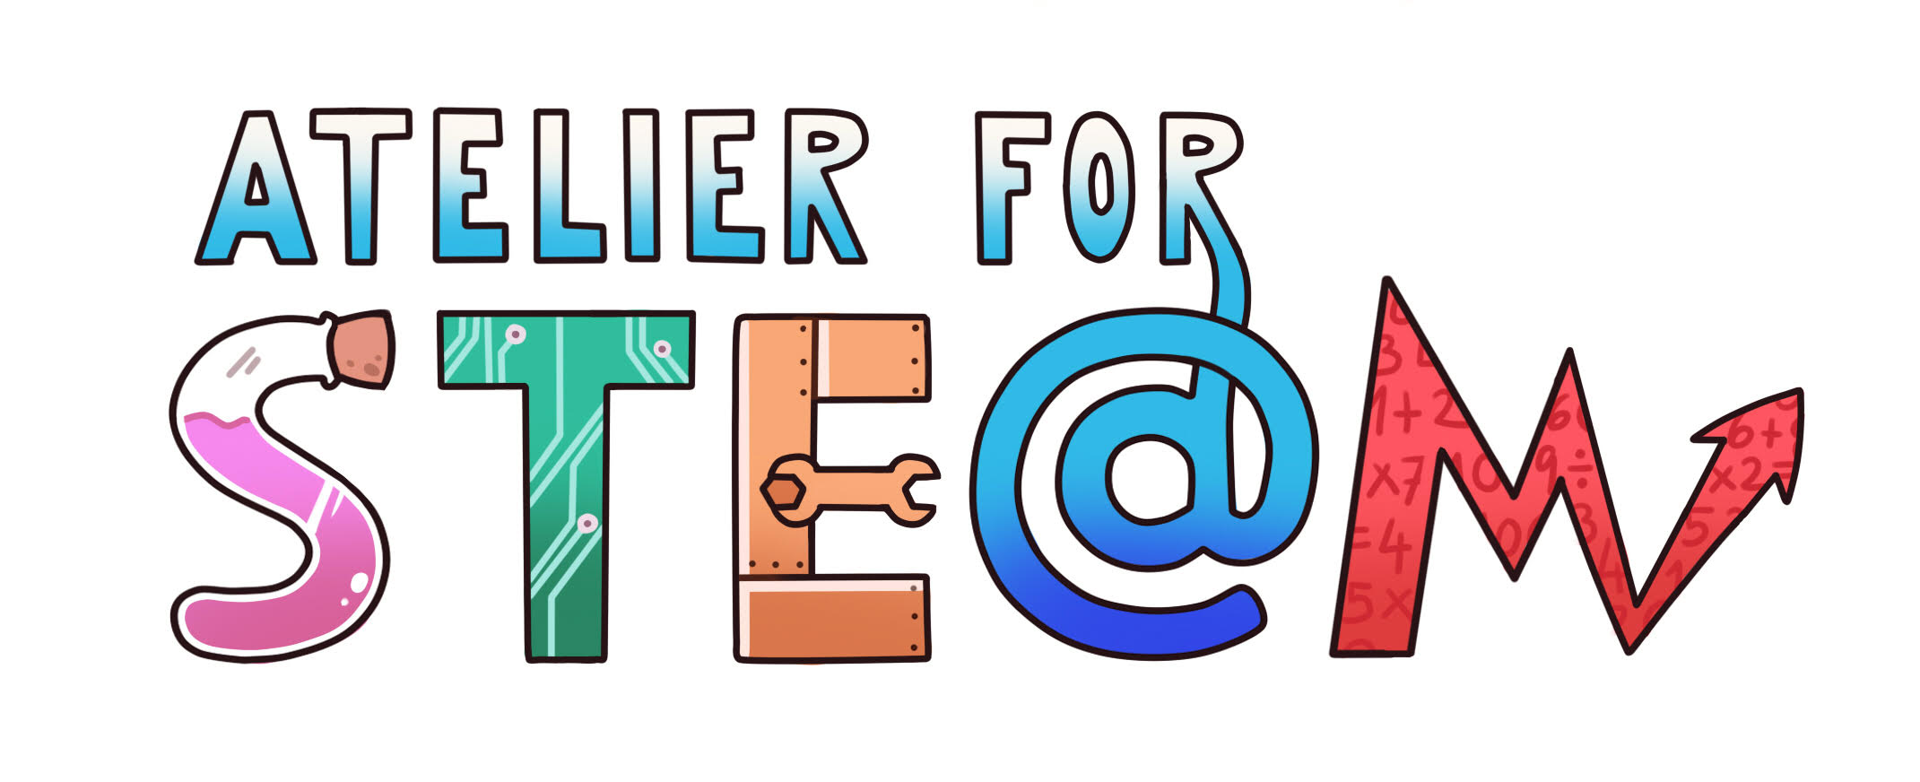 | Atelier for STE(A)M project.
Title | Water lesson
Content knowledge | Different aspects of water, words connected with water, problems connected with water, awareness of water as a global issue
Methodology | Project-based learning: students get tasks to research and present. They work in a group of 5.
Technology | Computers, internet.
Duration | 90 minutes
Target group (age, course) | Student aged 15, English lesson
Resources | https://www.nationalgeographic.com/environment/sustainable-earth/water/  https://www.youtube.com/watch?v=rXepkIWPhFQ  other webpages that students choose themselves
Learning Objectives, Skills and competencies | Students research the topic they are given in the group. The aspect covered are:  - Reading and summarizing an article from National Geographic titled:Sustainable Earth: Water  - Researching and presenting different aspect of bottled water.  - Listening and analyzing the meaning of water in popular songs.  - Discussing problems with water in their everyday lives.  - Learning and teaching expressions, idioms and phrases with water in English.  - Watching and reporting about How to make filthy water drinkable based on a TED-talk by Michael Pritchard.  Students learn many 21st century skills; teamwork, collaboration, awareness of the environment, leadership skill, presentation skills, using internet tools, critical thinking, creating opinions based on facts, comparing reliable sources, and others.
Learner’s Role  Learning space | Students are given short instructions and have to proceed with the research on their own. They have to divide their roles in a group and present the result of their work. The teacher merely supervises, encourages and answers questions.  Students work in a classroom equipped with computers – each student has access to a computer and can work individually.
Description  Scenario Narrative  10 sentences or more  the main ideas of the scenario | The teacher prepares topics to discuss and some material, so that not too much time is lost. The students are told to divide into 6 groups of 5 students. Each group is given instructions on a piece of paper. They are told that they have 30 minutes for research and 10 minutes to prepare their presentation for the class. The rest of the time will be devoted to listening to presentations, learning from what each group has done, and class discussion. The instructions the students are given are:  GROUP 1  Read the article on this website and prepare to present its main ideas. Prepare a powerpoint with 5 slides to help you with the presentation.  https://www.nationalgeographic.com/environment/sustainable-earth/water/  GROUP 2  Research bottled water  Find answers to these questions: How many brands are there? What is the price range? What does it depend on? Plastic or glass? What is the quality? How is the quality measured? Where do they sell most of it? (Why?)  Research any other issues/ questions that you are interested in. Prepare to present your research. Prepare a powerpoint with 5 slides to help you with the presentation.  GROUP 3  Water in songs  Find at least 5 songs that speak about water. What do the songs say about water? What ideas is water associated with?  Use your earphones when listening so as not to disturb the rest of the class.  Prepare to present your research. Prepare a powerpoint with 5 slides to help you with the presentation.  GROUP 4  Discuss problems with water  What are some modern, current problems connected with water? Are some problems more serious than others? Can you think of solutions to these problems?  Discuss all these questions as a group . Prepare to present your opinions. Prepare a powerpoint with 5 slides to help you with the presentation.  GROUP 5  Expressions, idioms and phrases with water  Research what are some common expressions, idioms and phrases in English that are connected with water. Choose 7 of those that you find the most interesting/ unusual/ useful/ … and teach them to your class.  Prepare a powerpoint with 7 slides to help you with the teaching/ presentation.  GROUP 6  Watch and report  Watch this video about water on Youtube:  Ted talk - Michael Pritchard: How to make filthy water drinkable  https://www.youtube.com/watch?v=rXepkIWPhFQ  Prepare to present the main ideas from the video. Prepare a powerpoint with 5 slides to help you with the presentation.
Learning Activities (created with Learning | Student s mostly do independent research that is also adjustable to their interests. Making a presentation at the end of their research makes them decide what is most important and learn how to present it in a clear, understandable way.
SEN (Reinforcement or ampliation) | Their knowledge will be checked in a writing exercise/ composition.

