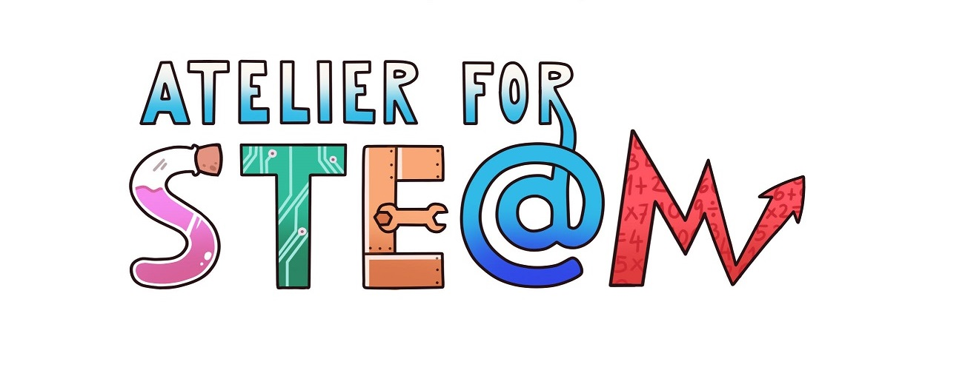 | Atelier for STE(A)M project.
Title | Physics and Soccer
Content knowledge | Movement. Trajectory.  Uniform line movement.  Uniformly accelerated rectilinear motion.  Pressure. Applications. Fundamental principle ofhydrostatics.  Kinetic and potential energies.  Mechanical energy.  Principle of conservation.  Work and power: units.
Methodology | Gamification, cooperativework, mobilelearning
Technology | PC / Internet  Mobile phone  Spreadsheet  Physics Toolbox app  Video Tracker
Duration | 8-9 sessions (50 minutes per session)
Target group (age, course) | 5-16 years (4th Secondary)
Resources | Book:Building physics through soccer
Learning Objectives, Skills and competencies  (aims to be accomplished) | Learn the physics concepts listed.  Use computer tools to search for information, to process data and to make graphs.  Use mobile devices as a physics laboratory.  Analyze the trajectory of an object from the analysis of videos.  That the students work cooperatively in the resolution of the proposed activities.  Know how to distinguish the relevant information from the non-relevant one.  Learn to learn.
Learner’s Role  Learning space | The activity has been carried out in cooperative work. The roles that have been defined are:  Coordinator: He takes care of each partner fulfilling his role.Organize the team so that the activities are carried out on time.  Secretary: He takes note of the activities.  He will share them with each student in the group.  Reporter: He takes pictures and video recordings.  In charge ofMaterial:He requests the material to the teacher or is responsible for obtaining  it so that it is ready at the beginning of the activity.  The activities have been developed in the classroom, in the computer classroom and on the school football field.
Description(of every lesson)  Scenario Narrative | It is about following the sequence of activities in the book Building physics through soccer.
Learning Activities | The activities that the student must carry out are distributed in the 7 sheets that the teacher will give sequentially.
SEN (Reinforcement or ampliation)  Conclusions | Find activities similar to those described in which you can study, take data and analyze different types of movement.  Search news in social media related to movement, speed and trajectory.
Improvements | Perhaps it would help the team to have a field notebook that facilitates the collection of data and notes.
evaluation/assessment | The objectives were widely fulfilled. The students enjoyed the activity. The activity was very well valued.
