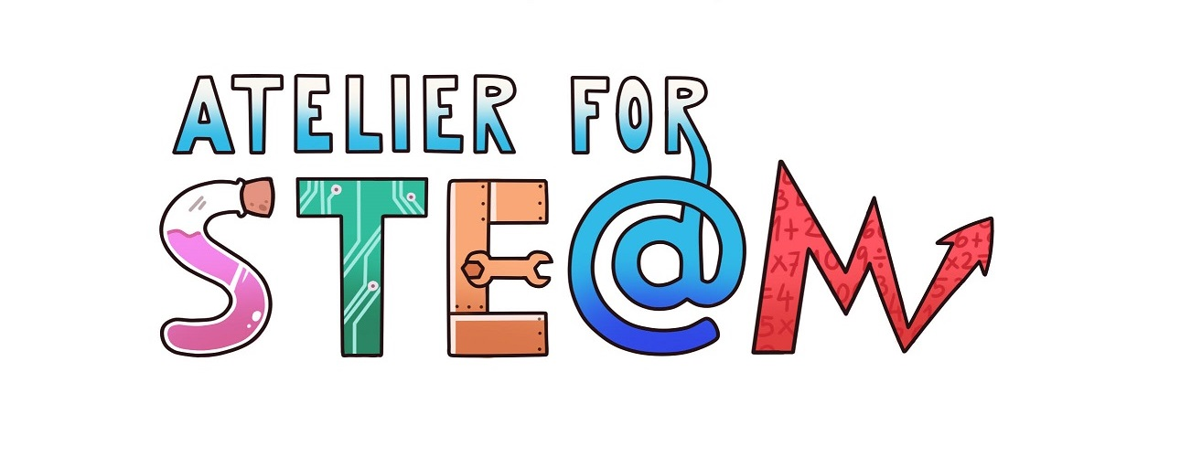 | Atelier for STE(A)M project.
Title | Playing with electric current
Content knowledge | Electrical magnitudes (Intensity, Voltage, Resistance).  Ohm's law.
Methodology | Inquiry in virtual environments
Technology | PC / Internet  PHET Colorado Virtual Laboratories:  https://phet.colorado.edu/
Duration | 2 sessions (50 min per session)
Target group (age, course) | 14-15 years (3rd Secondary)
Resources | Virtual Laboratory "Circuit construction kit (CC only)"  https://phet.colorado.edu/es/simulation/legacy/circuit-construction-kit-dc-virtual-lab
Learning Objectives, Skills and competencies  (aims to be accomplished) | That the student is able to find the relationship between the electrical magnitudes (Ohm's law).  That the students work in groups in the resolution of the proposed activities.  Know how to distinguish the relevant information from the non-relevant one.  Learn to learn.
Learner’s Role  Learning space | The activity will work by pairs, who work in the same PC.
Description(of every lesson)  Scenario Narrative | The teacher explains the electrical magnitudes: intensity of electric current, voltage and resistance.  The teacher gives a file (Annex) and proposes that students build a simple circuit to check the relationship between these magnitudes. That relationship is known as Ohm's Law.
Learning Activities | ) Read carefully the file that the professor has given you.  b) Find the virtual laboratory PHET Colorado "Circuit construction kit (CC only)" and identify the elements that appear. Find information about those you do not know.  c) Build a simple circuit (only one battery, one bulb or resistance) and connect it.  d) Follow the instructions in the teacher's file (Annex).
SEN (Reinforcement or ampliation)  Conclusions | Students can perform more complex circuits and verify Ohm's law.
Improvements
evaluation/assessment | The objectives of the activity have been adequately met.

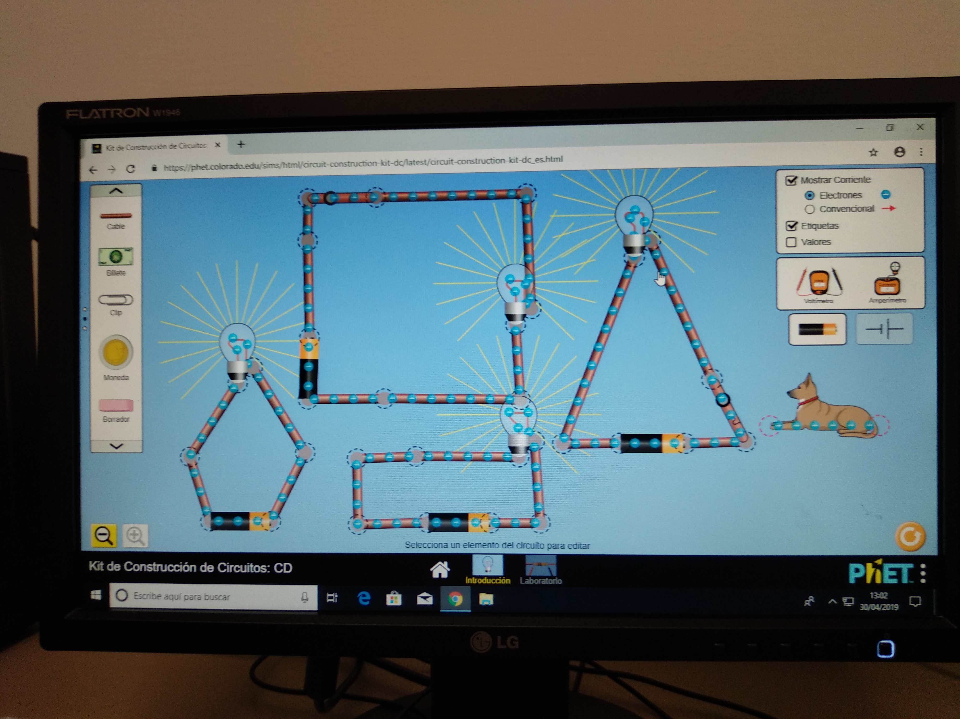
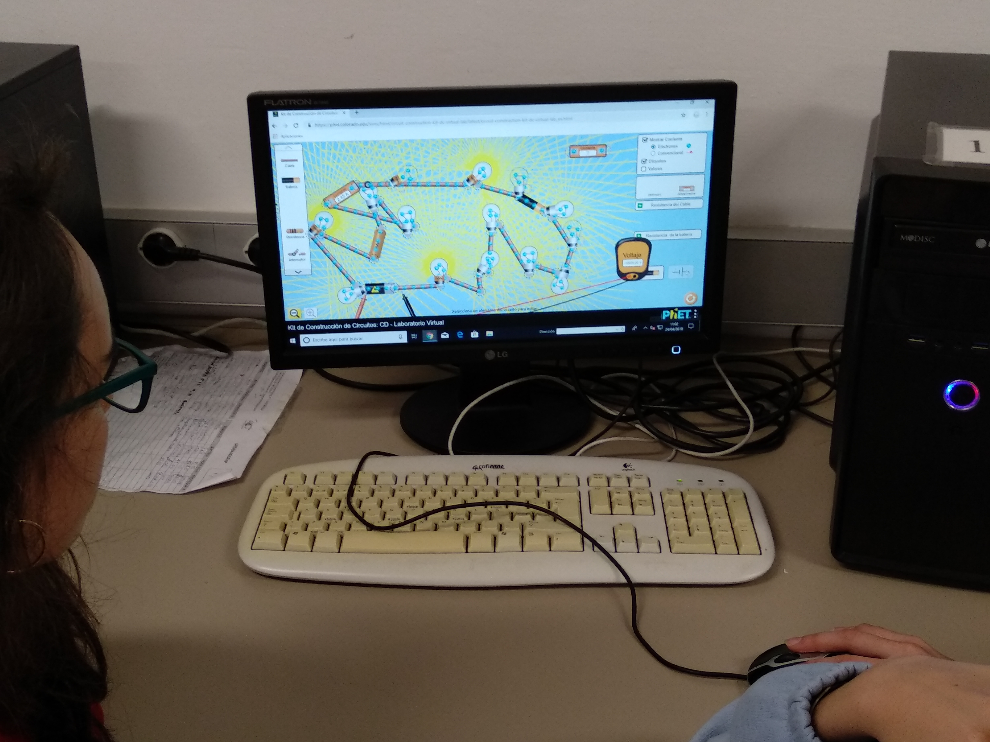
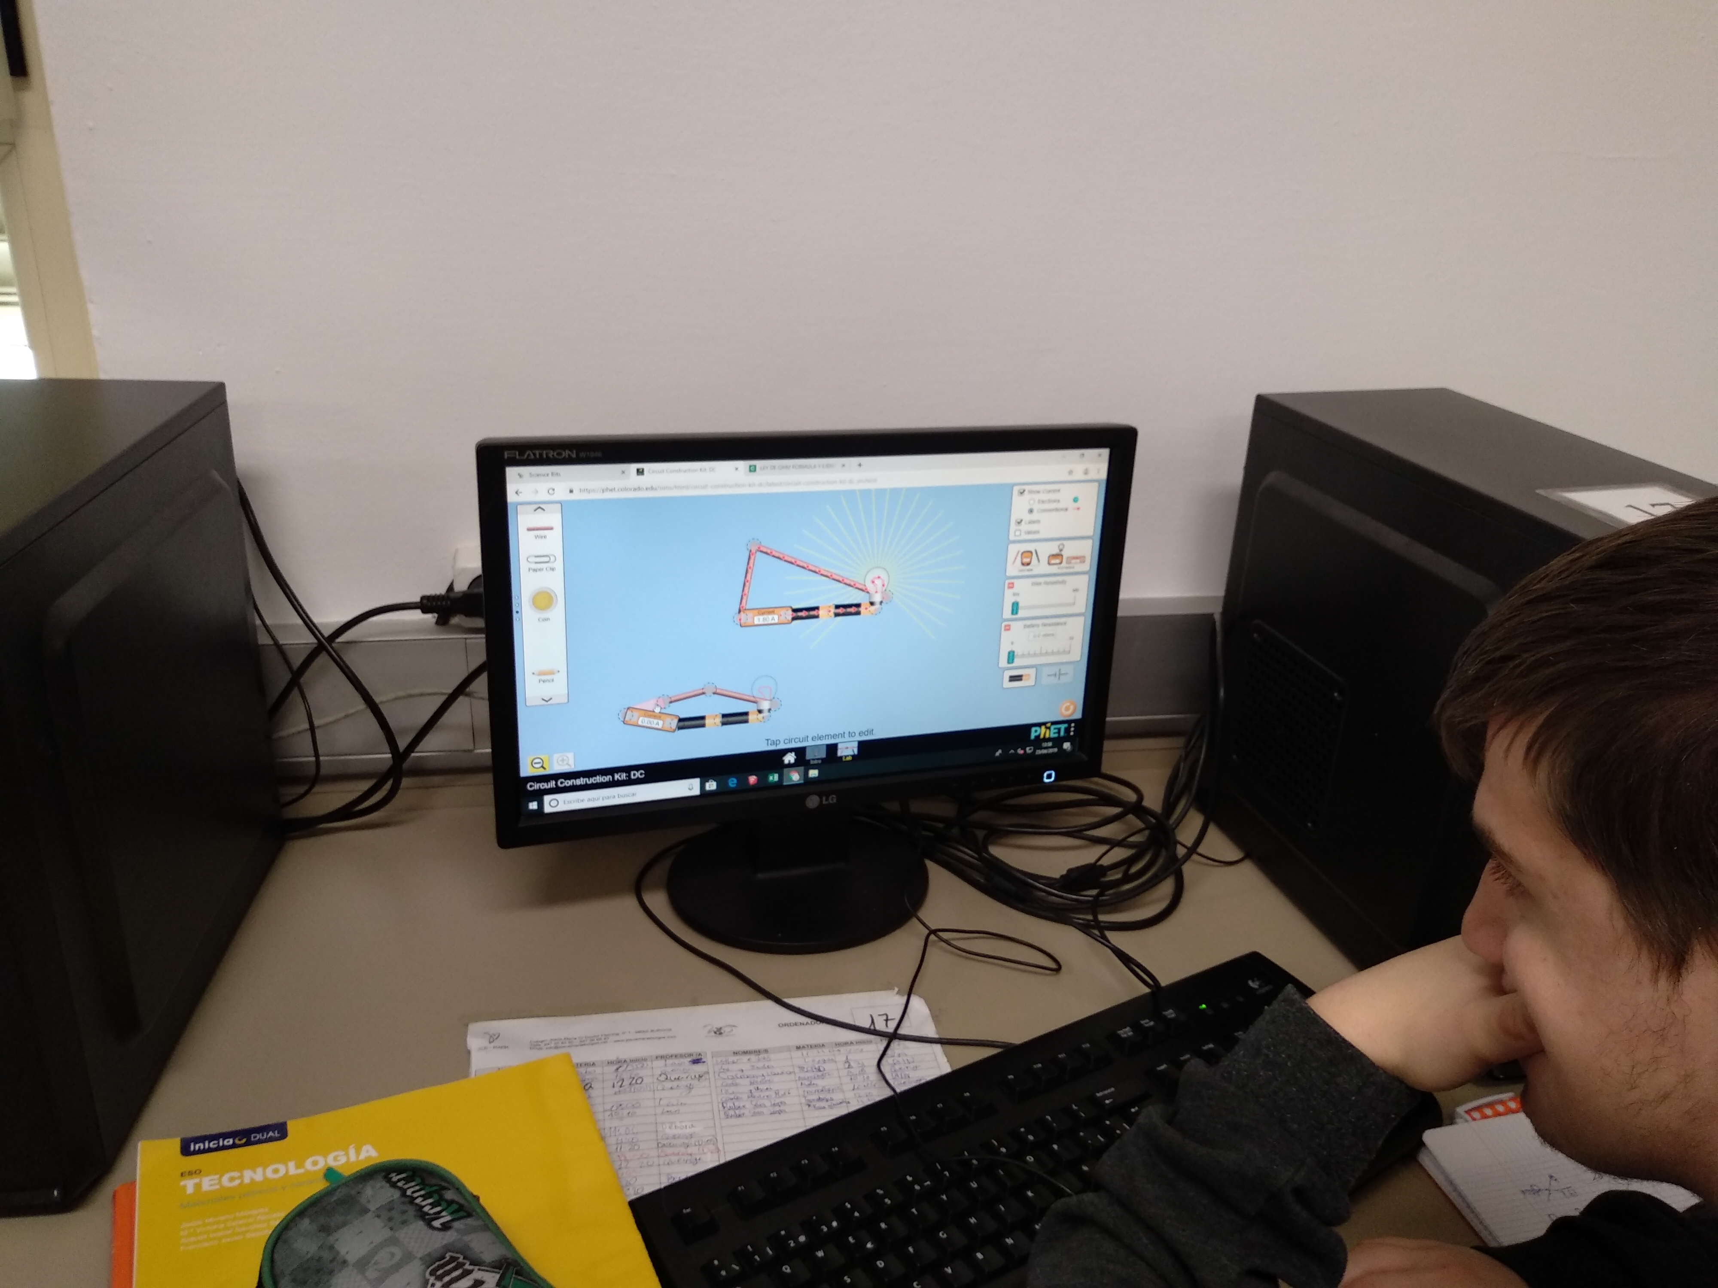

APPENDIX
The following activity allows you to obtain the relationship between the electric current I, the potential difference, V, and the resistance, R, in a circuit. This relationship is called Ohm's law.
For this, you will use the virtual laboratory "Circuit construction kit (CC only)", which you will find on the following page:
https://phet.colorado.edu/es/simulation/legacy/circuit-construction-kit-dc-virtual-lab
Make a montage like the one in the figure:
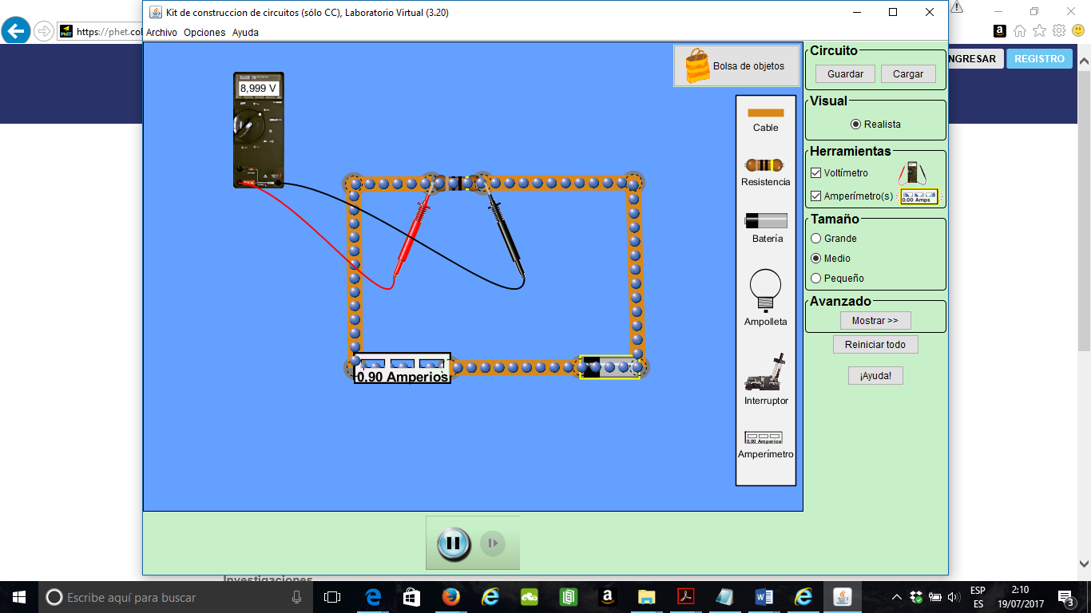
The elements that you will use are: resistance, battery, cable, ammeter and voltmeter. See how you should place the ammeter and the voltmeter.
Choose the value of the resistance you want, change the voltage of the battery, and note the reading of the instruments. Realizes the difference of potential graph versus Intensity.
V(V)
I (A)
V(Volts) | I (Amperes)

Answerthefollowingquestions:
a) How is the graphic relationship you have obtained between V and I?
b) Write the mathematical relationship that you have found between the potential difference and the intensity that circulates through the resistance.
c) Do the experience again changing the value of the resistance.

