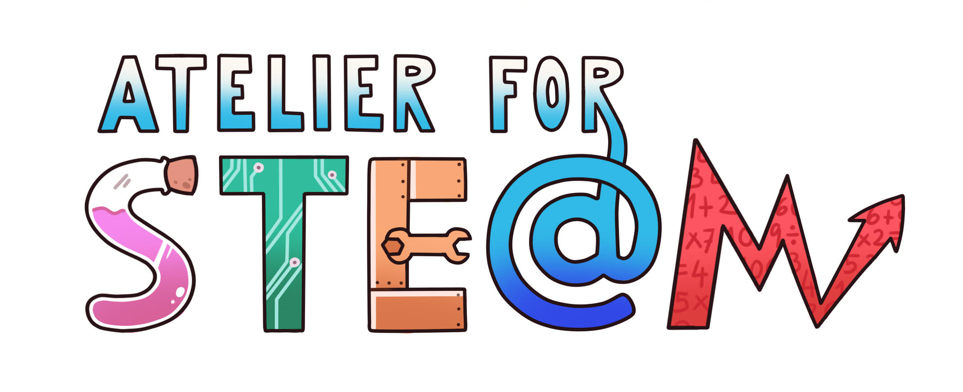 | Atelier for STE(A)M project.
Title | Beeswax
Content knowledge | Interdisciplinary collaboration: Physics, Biology and History. Exploring the use of beeswax and its characteristics
Methodology | Independent execution of experiments, BYOD
Technology | PPT, BYOD
Duration | 40 mins
SAMR model (level of transformation technology produce) | Computer, PPT, BYOD
Target group (age, course) | 13 – 15 years old, Physics, Biology and History
Resources | https://sl.wikipedia.org/wiki/%C4%8Cebelji_vosek  https://en.wikipedia.org/wiki/Beeswax  Esenko, I. O čebelah in čebelarstvu v Sloveniji, Ljubljana: Družina d.o.o., 2018.
Learning Objectives, Skills and competencies  or. (Aims to be accomplished) | - Interdisciplinary knowledge exchange  - Independent execution of experiments  - To use the formula to calculate density
Didactic sequence  -Description of every lesson  with added attention to the diversity of students | Part 1: After a brief introduction on the topic by the class teacher, the first student explains how beeswax is produced using PPT. Another student tells how beeswax used to be produced wand what it was used for in the past. The third student tells where beeswax is used today.  Part 2 (the experimental part): Students get into groups of 4. Although with the help of more experienced students they try to independently measure the density of beeswax and measure its melting point.  They consult the instructions of the worksheet provided by the teacher.  Once the measurements have been done, a discussion follows on the execution of the potential errors of the measurements and each group reports on the error margin in their experiments.  Eventually the students complete all worksheets.  They answer the questions on the worksheets independently and consult the internet for any information and/or further reading. (BYOD)
Evaluation  (what are we going to evaluate, how, whom…) | The knowledge students have acquired will be tested in the upcoming written examinations.
Conclusions | Knowledge acquired in a subject can me be used in other subjects as well.
Improvements | Students have improved their experiment skills and public speaking skills.

